AWS Windows Instance

ESBPII LAB 1

Manoj Amarasekera

IT13124922

**Amazon EC2 Windows Instance**

1. 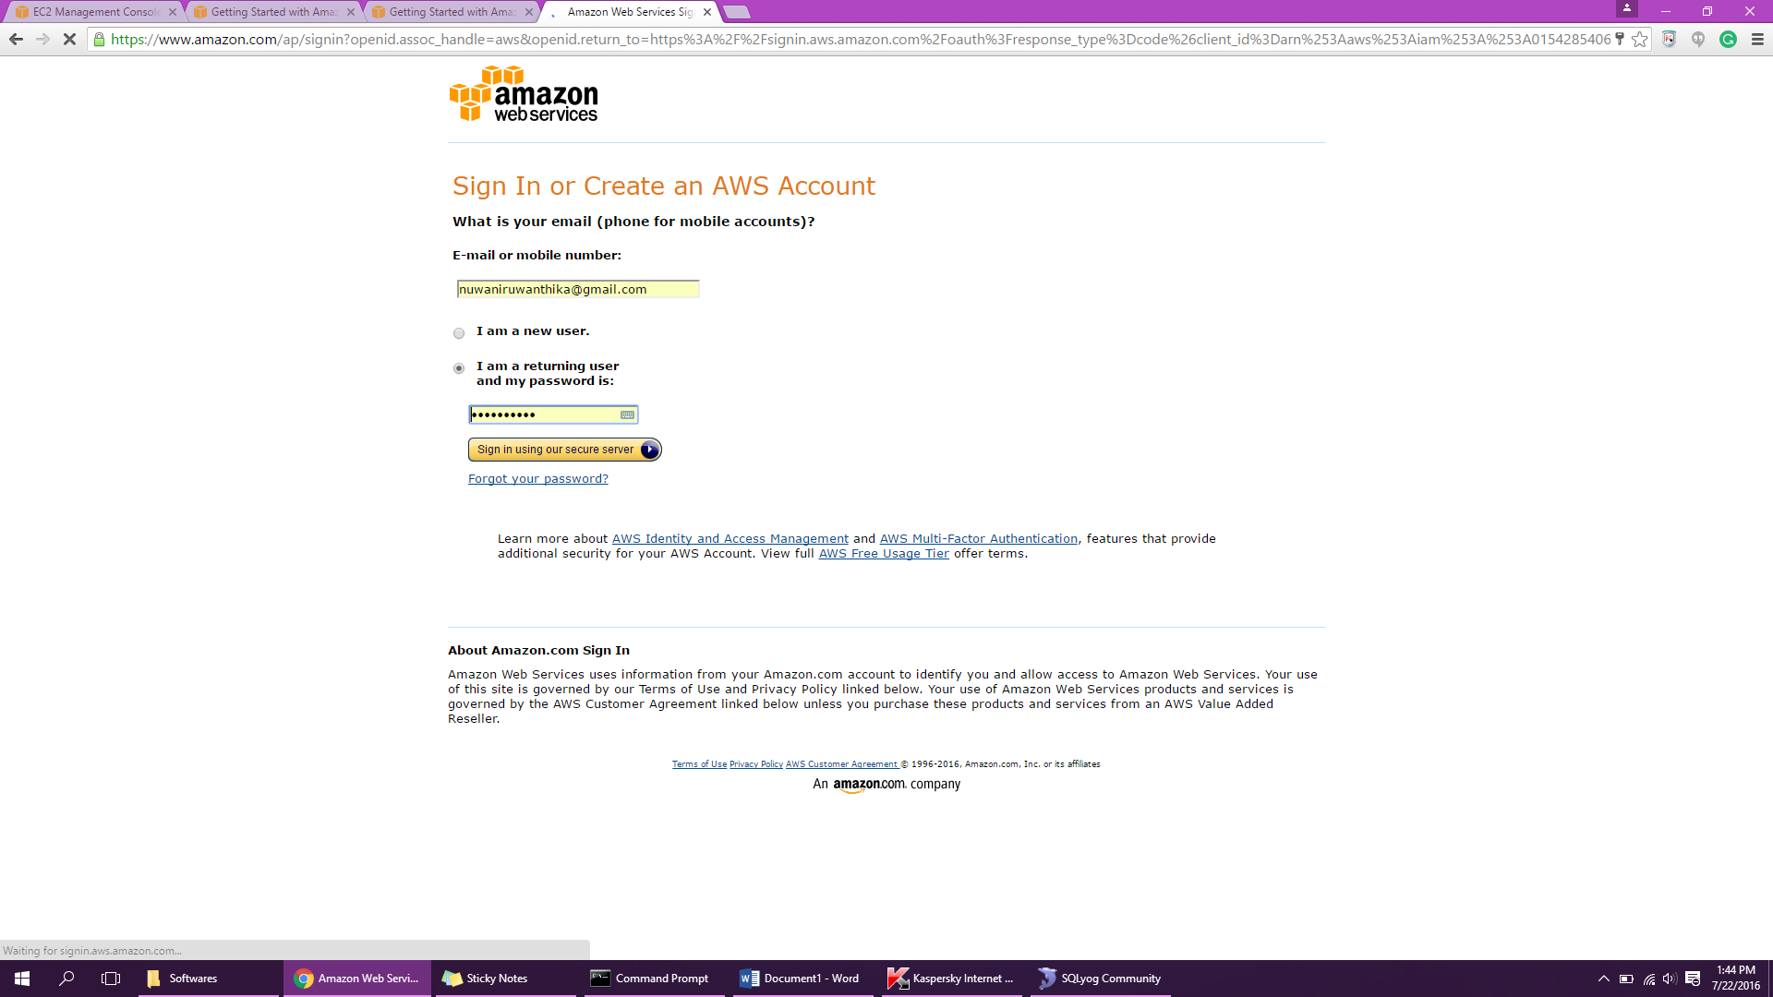Create the account.
2. Select the EC2 instance.

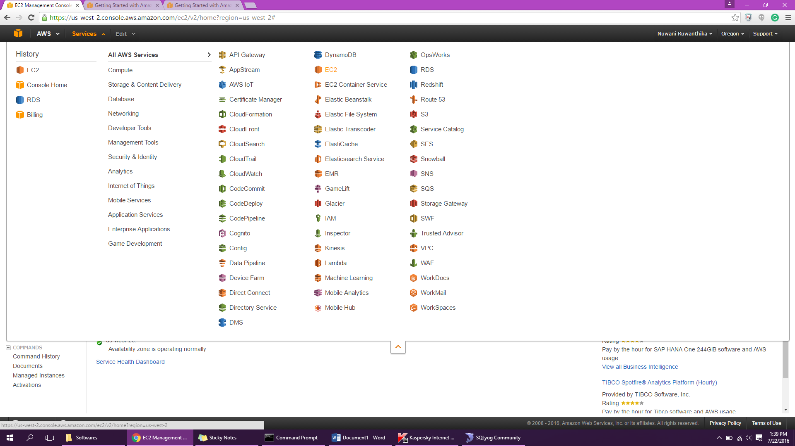

1. 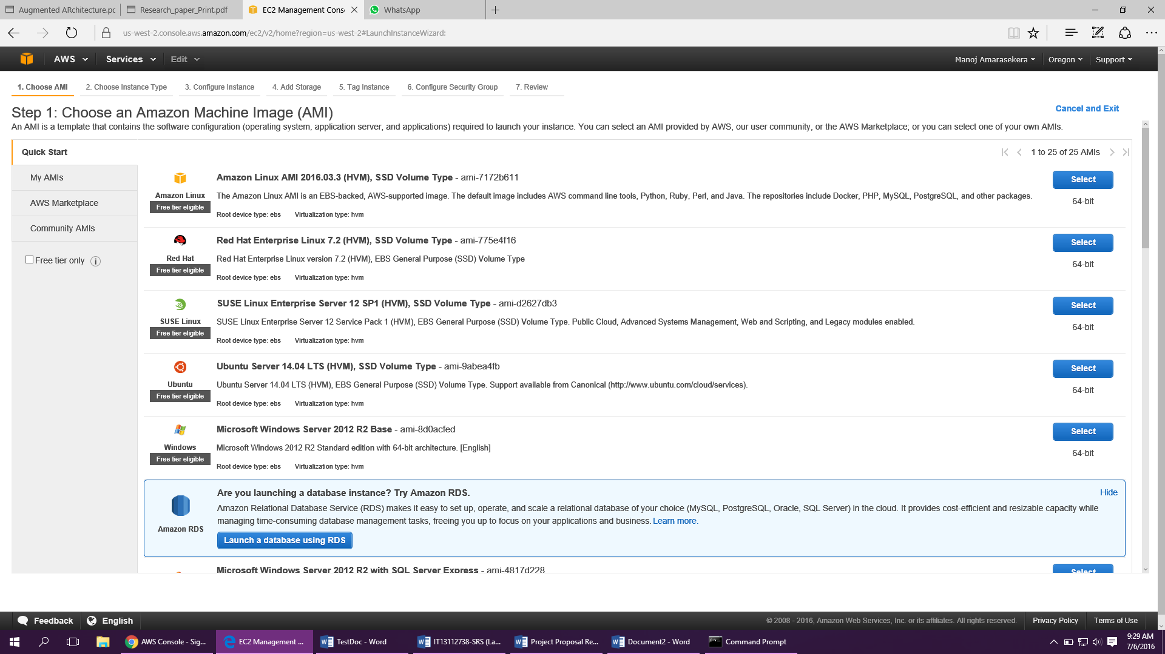Choose an Amazon Machine Image (AMI)
2. 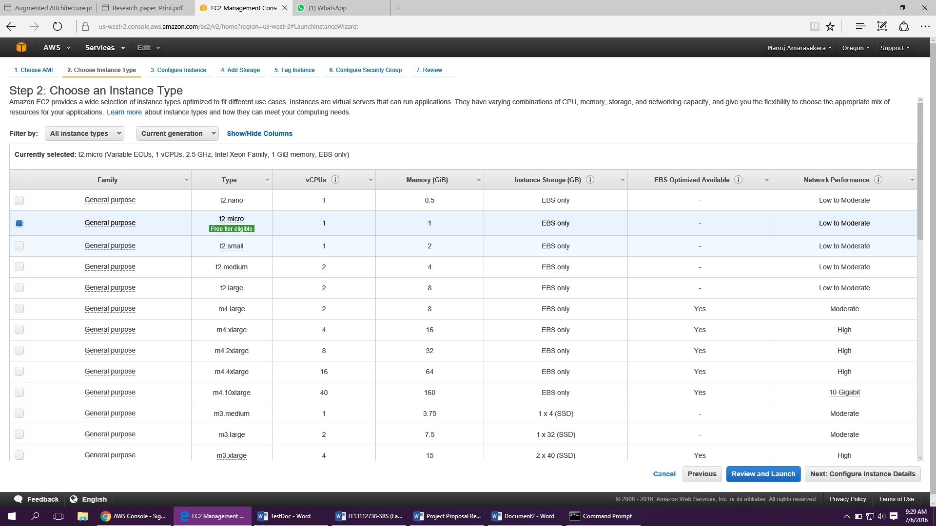Choose an Instance Type
3. Choose Review and Launch to let the wizard complete the other configuration settings.

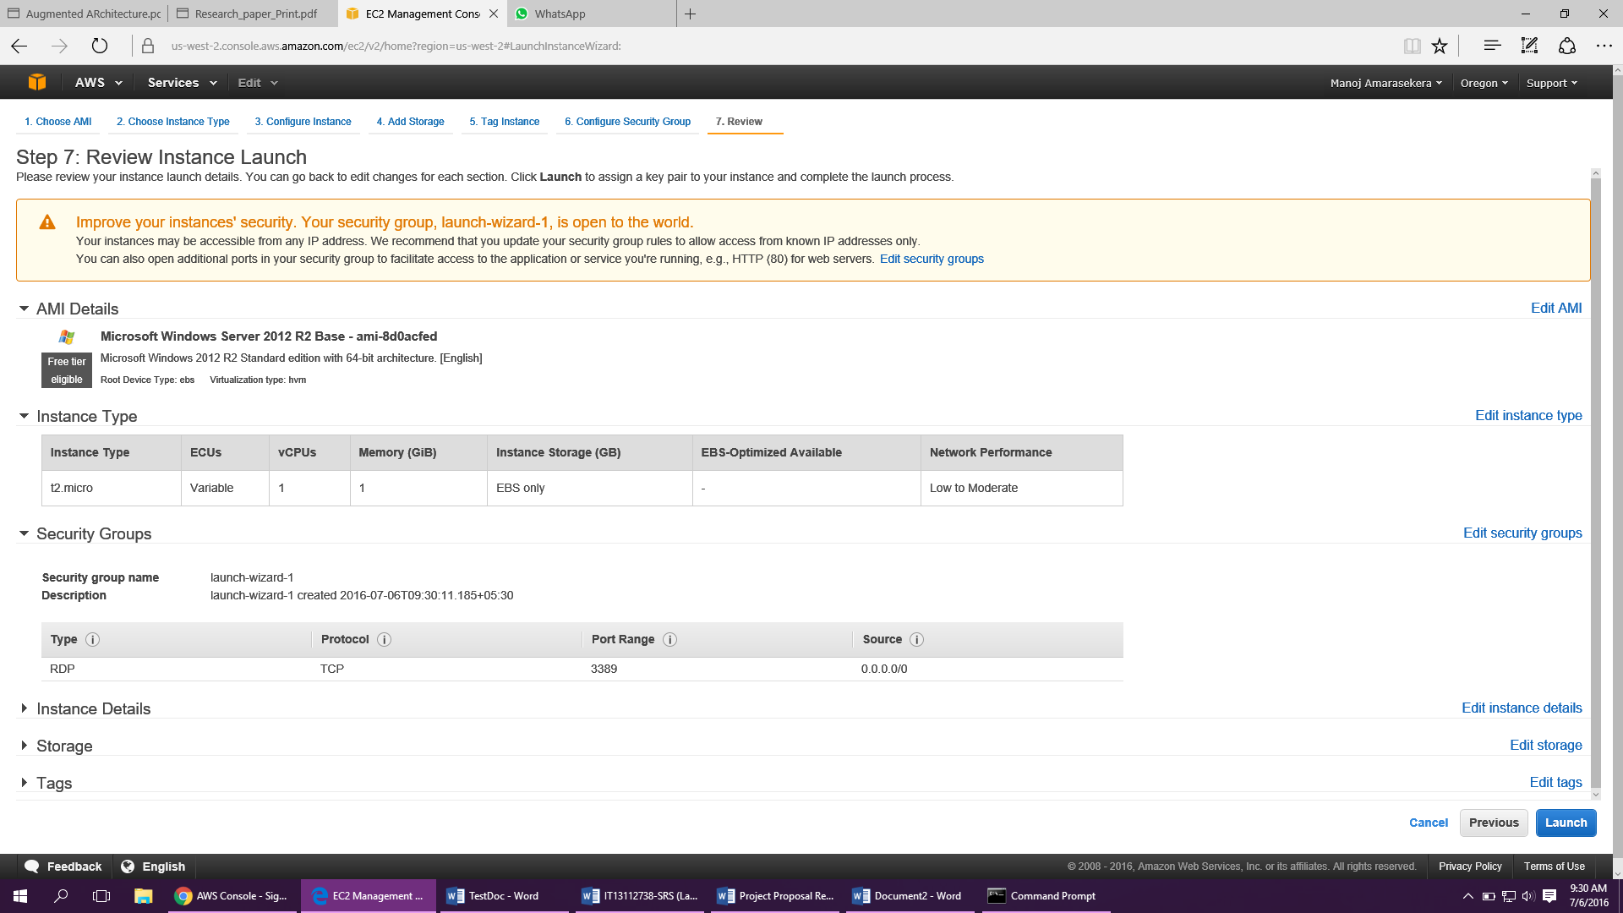

1. 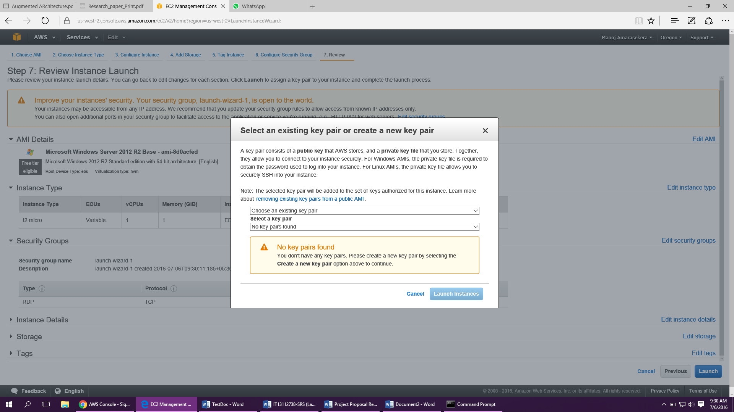Select an existing security group.
2. 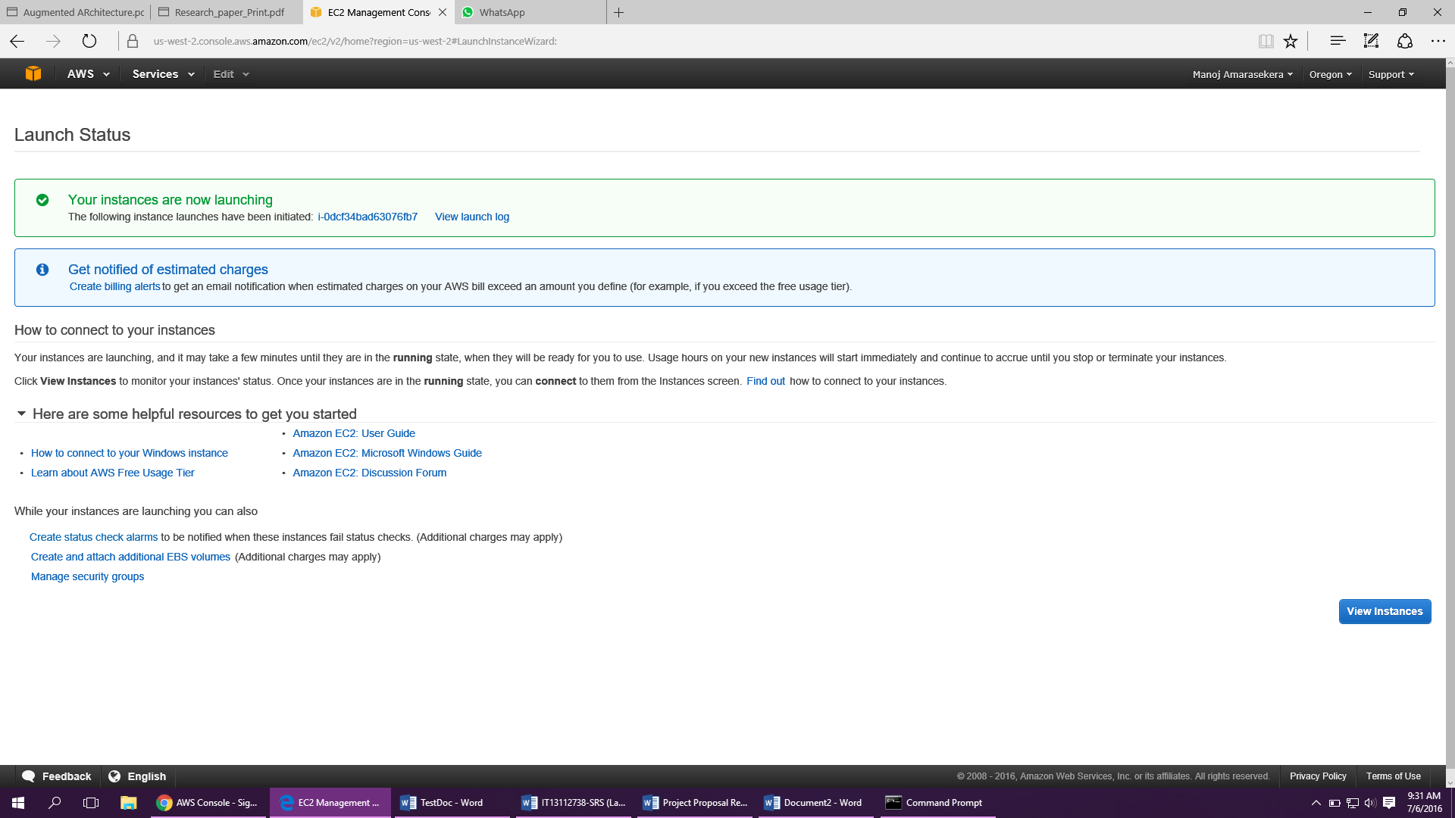Select **Create a new key pair 🡪** Enter Key pair name 🡪 choose **Launch Instances**.
3. 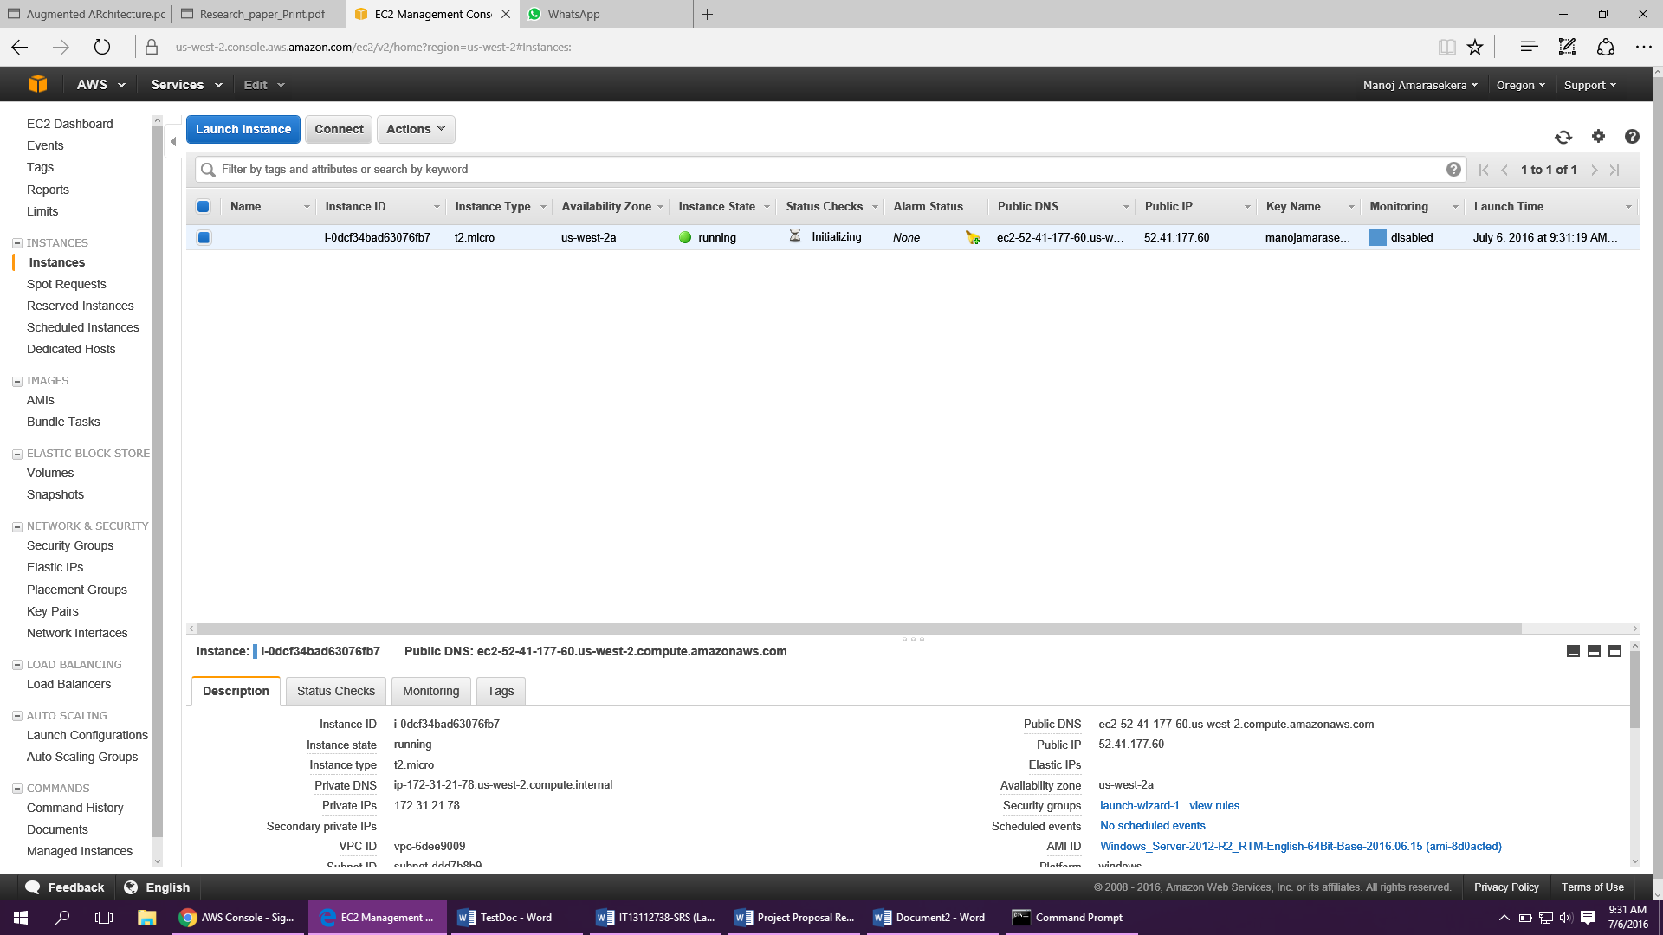Choose **View Instances**
4. 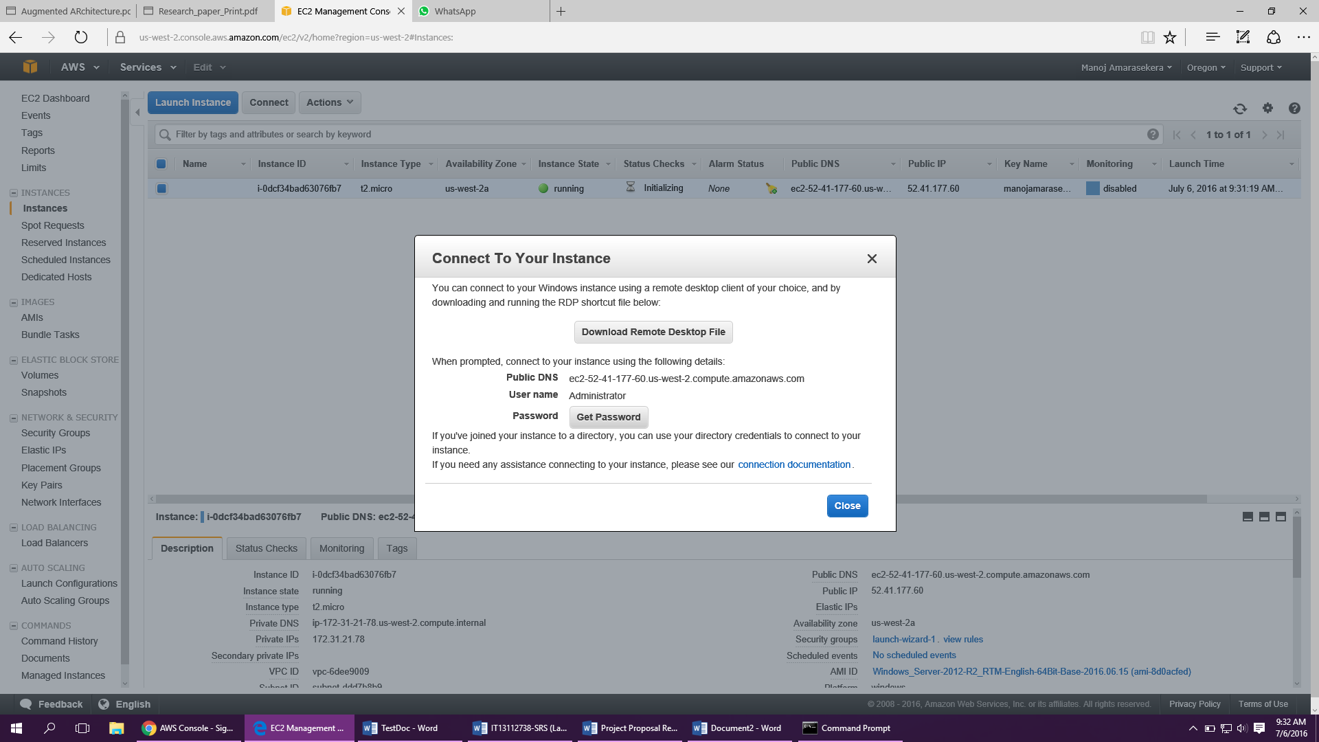In the **Connect to Your Instance** dialog box, choose **Get Password**.
5. 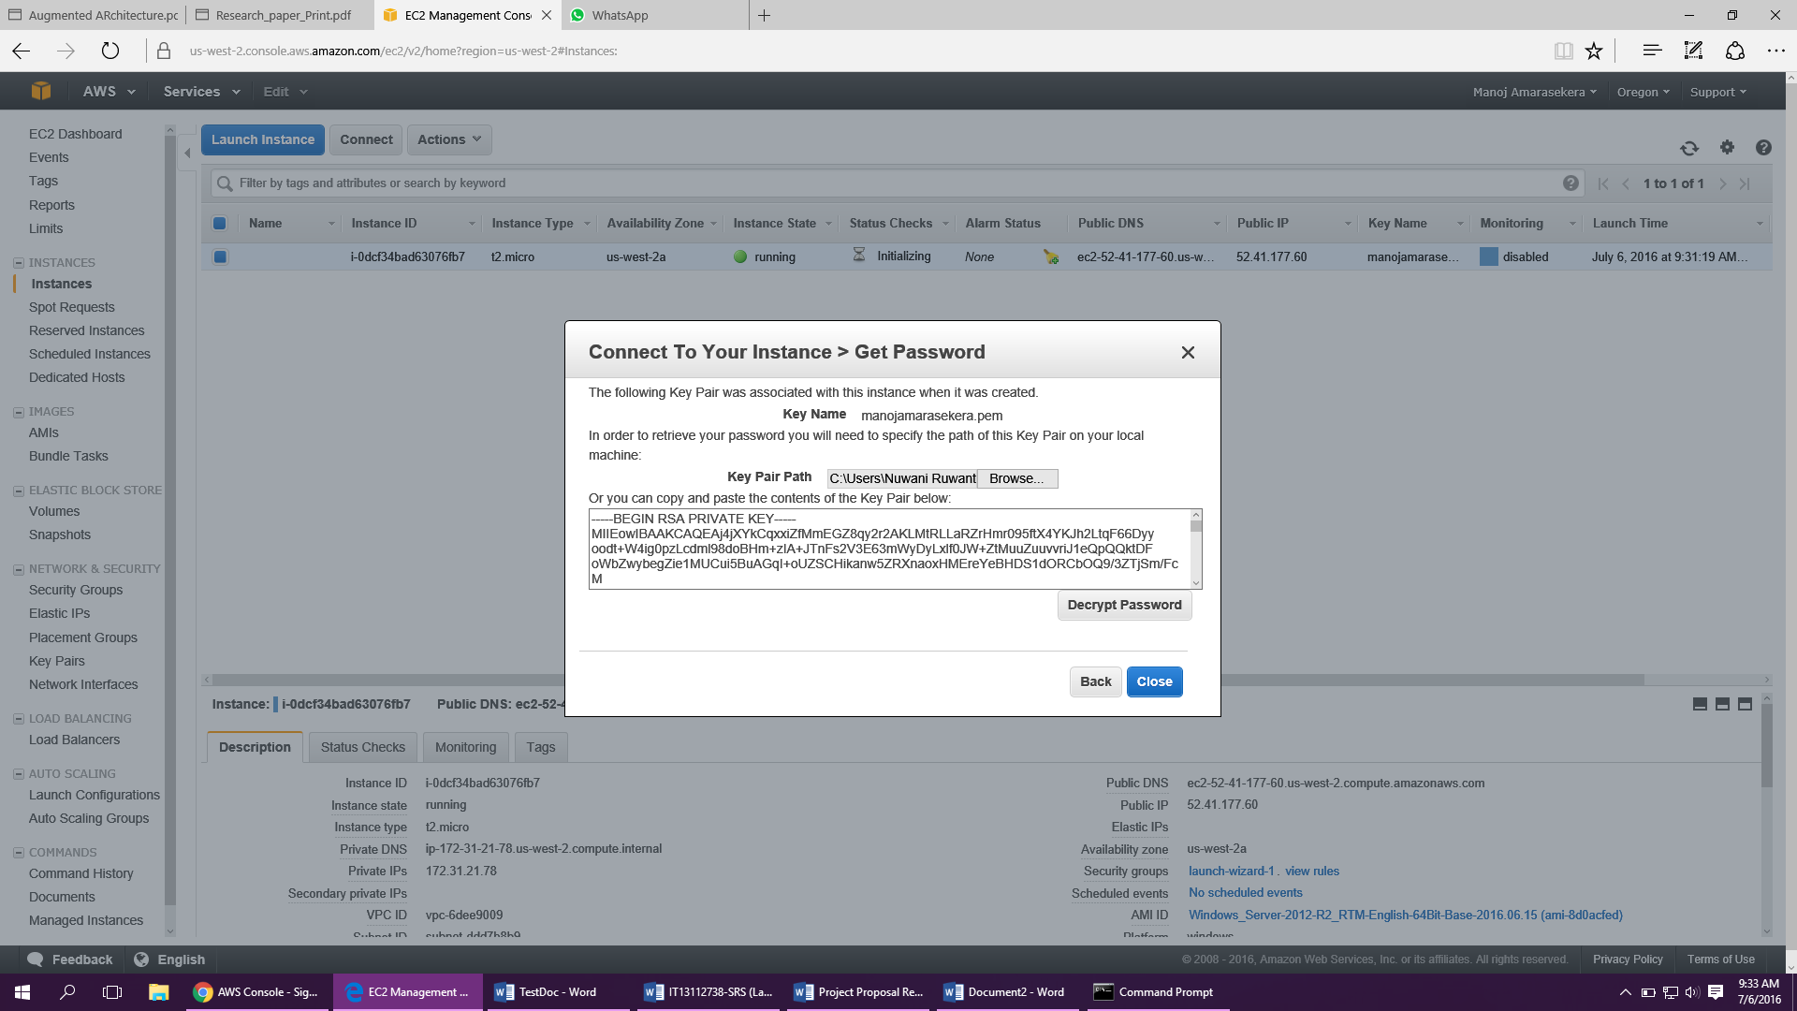Choose Decrypt Password.
6. 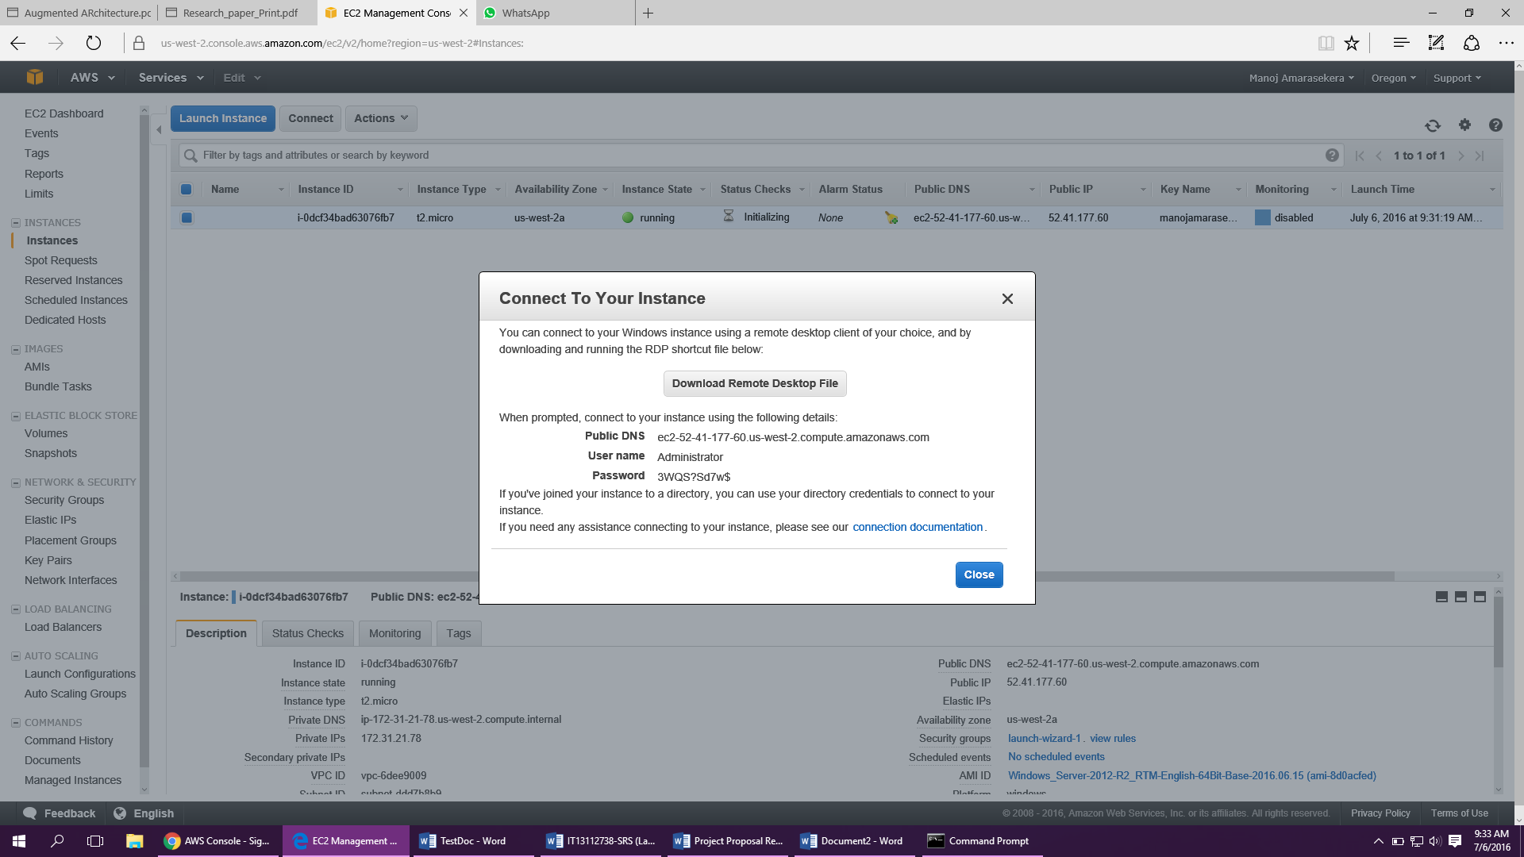Choose **Download Remote Desktop File**.
7. When prompted, log in to the instance, using the administrator account for the operating system and the password that you recorded or copied previously.
8. 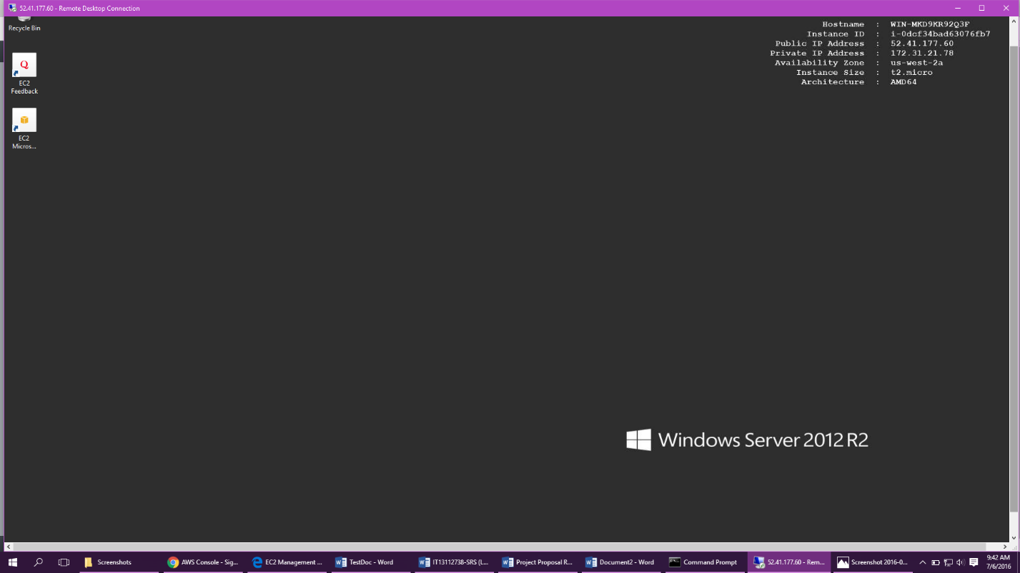The launched Amazon EC2 Windows Instance.